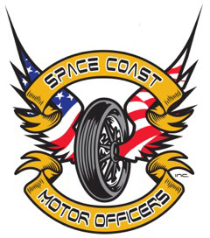

SPACE COAST MOTOR OFFICERS, INC
SPONSORSHIP OPPORTUNITIES

Platinum Package-$5000
- Business name on all shirts
- 10 x 10 vendor spot
- All media advertising for event for 12 months
- Daily shoutouts at event
- Logo on all posters and event flyers
- Banner displayed at event
- Invitation for 4 to the banquet
- Sponsorship plaque
Gold Package-$3000
- 10 x 10 vendor spot
- All media advertising for event for 12 months
- Daily shoutouts at event
- Logo on all posters and event flyers
- Banner displayed at event
Silver Package-$1000
- All media advertising for event for 12 months
- Daily shoutouts at event
- Logo on all posters and event flyers

**Deadline for sponsorship packages September 15th, 2022**

